THE INSTITUTE OF RESEARCH IN DIGESTIVE HEALTH
RESEARCH AND TECHNOLOGIC FACILITIES IN DIGESTIVE SCIENCE

New group leader positions at IRSD Institute, Toulouse, France.
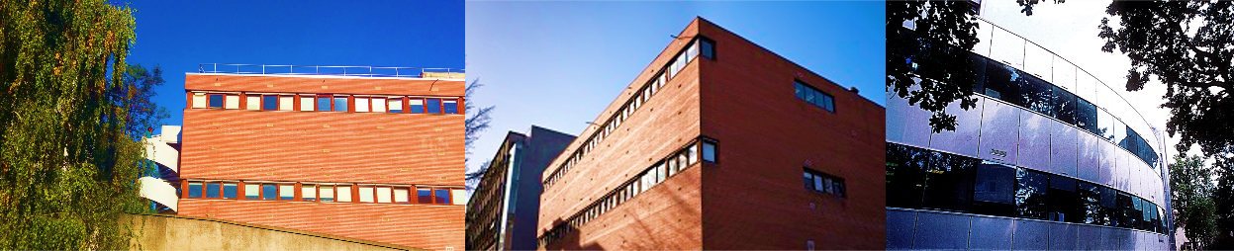

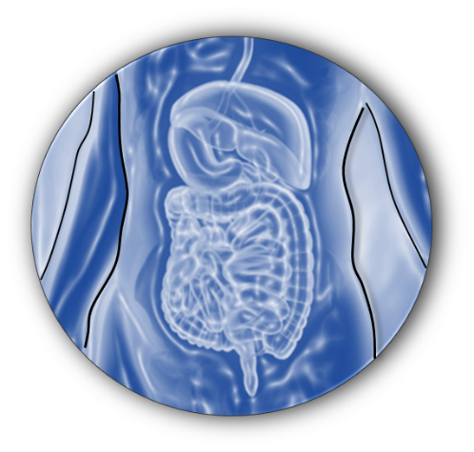

IRSD is a new very active Institute with interests in fundamental and translational research in the field of physiopathology of the digestive tract. The Institute brings together 80 scientists and supporting staff within a single research structure composed of 5 research teams with international visibility. Our Institute is worldly recognized for his work on inflammatory bowel diseases, motility disorders, neurogastroenterology, dysregulation of iron metabolism, dysfunction of the intestinal barrier, microbiota, and mucosal immunity.

IRSD is affiliated to INSERM, INRA, the National Veterinary School and the University of Toulouse. The Institute is located inside the Purpan Hospital in Toulouse and has access to excellent core facilities with highly qualified staff for flow cytometry and cell sorting, cell imaging and histology. There are also large EOPS mouse housing facilities on site, with L2 facilities for infectious models.

In order to reinforce its research capacity, IRSD is looking for new junior group leaders addressing basic, clinical or translational research questions related to the physiopathology of digestive with, if possible, a special interest for epigenetic regulations.
Young scientists of any nationality, at junior or midcareer level, and with a good track record of publications in internationally recognized journals, are encouraged to apply. Candidates are expected to establish independent national and international research projects and should have the qualifications to apply for ATIP/AVENIR (270 K€/3 ans) or ERC grants. They will receive a strong support from the IRSD to obtain tenured positions at INSERM or CNRS.
More information on the Institute are available on the IRSD web site http://en.irsd.fr/

Applications should be submitted to nathalie.vergnolle@inserm.fr and must include:

- Full CV, including a list of publications
- Past and current research interests
- Future research proposals
- Letters of recommendation by referees (should be submitted with the application).
http://en.irsd.fr/ www.irsd.fr

